ព្រះរាជាណាចក្រកម្ពុជា

ជាតិ សាសនា ព្រះមហាក្សត្រ

**Web Design**

**Web Design Final Project**

**GROUP: I3-GIC1-A**

**Name of Students ID of Students Score**

1. DIN Rasy e20221071 ……….

Teacher: Mr. LIV Bunthorn

Academic year 2024-2025

**Report: Nham Nham Restaurant**

1. **Topic Overview**

Nham Nham Restaurant is a modern, responsive website designed to promote a food delivery and dine-in service. The site showcases a wide range of dishes and offers quick, convenient online ordering and reservation features. It includes pages such as Home, About, Menu, Dish Details, Cart, Reservations, Contact, and Profile.

1. **Target Users**

* Students: Often too busy to cook, looking for quick meals between classes.
* Office Workers: Need fast, delicious lunch options during short breaks.
* Families: Want convenient meal delivery or dine-in options without daily cooking stress.

1. **Identified Problems**

* People have limited time to cook, especially during work or study.
* Hard to find food quickly that meets both taste and time needs.
* Existing platforms are either too complex or don’t show enough detail about dishes.
* Users want a faster way to order meals, view menus, and make reservations.

1. **How the Website Solves These Problems**

* Clear, fast-loading menu page with categories and detailed images.
* Easy dish details view with description and visuals.
* A responsive layout ensures users can access the site from any device.
* Includes cart and reservation features for convenience.
* Designed to be intuitive and friendly, reducing time spent on ordering.

1. **UI Design (Figma)**

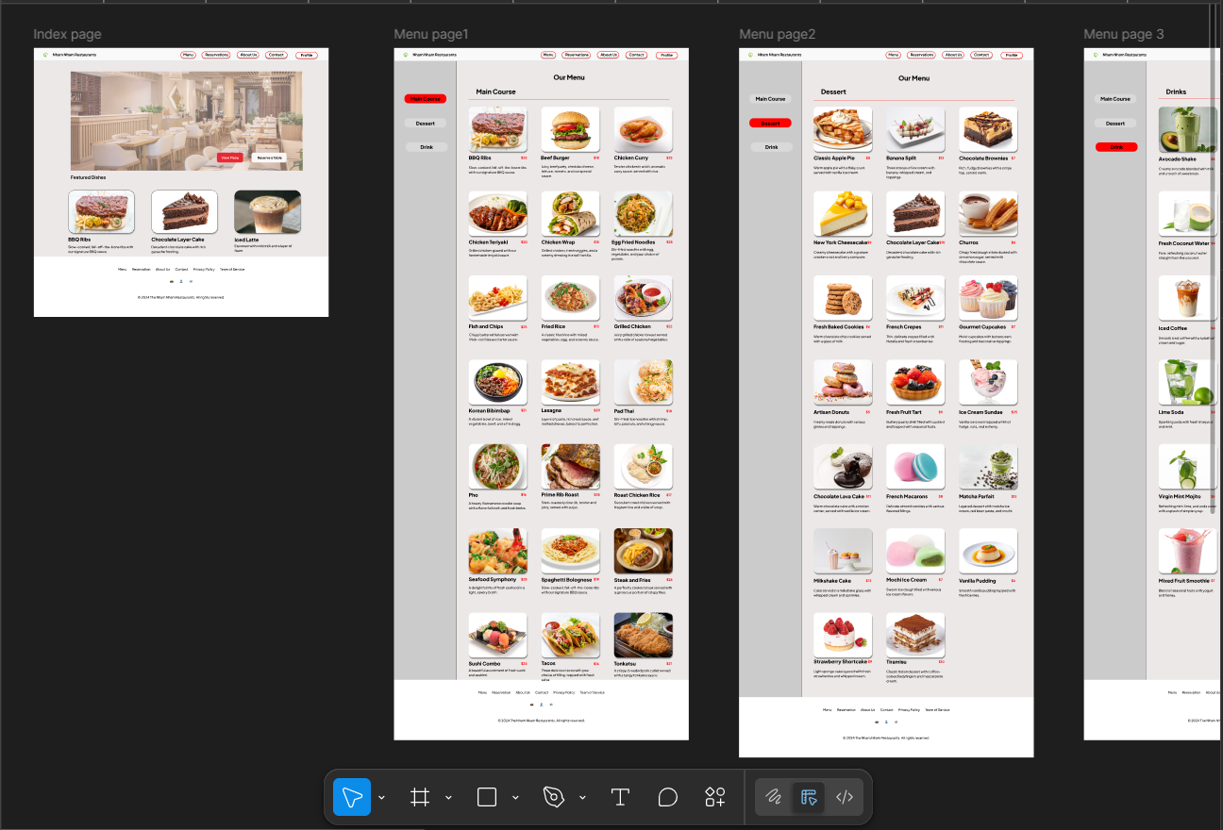 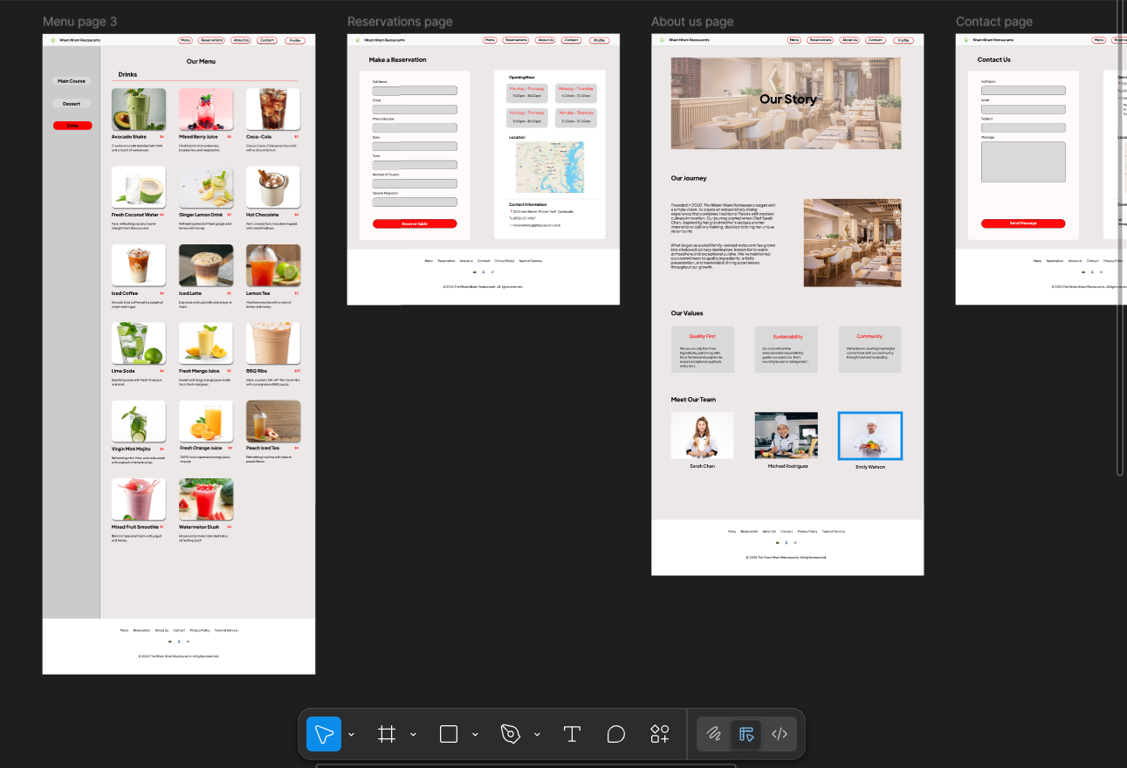 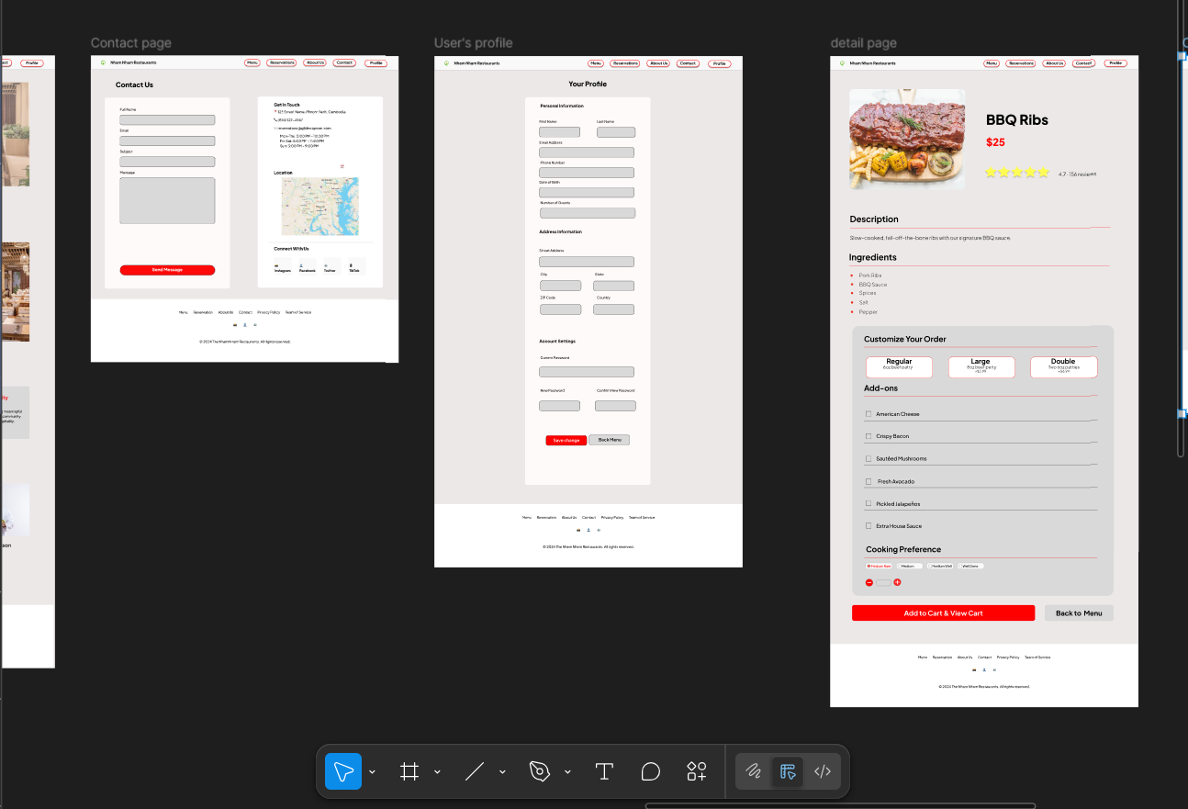 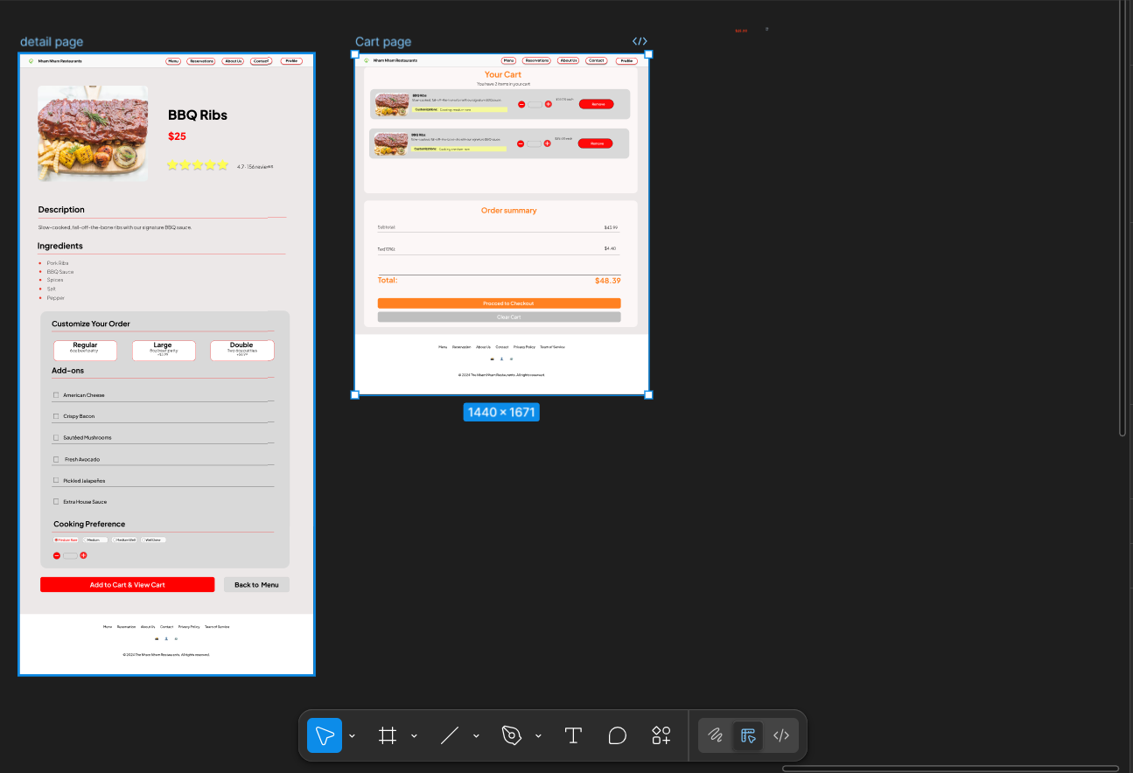

1. **Pages Developed**

* index.html – Home page
* about.html – Restaurant intro and mission
* menu.html – Full dish listing with images
* dish-details.html – Expanded view of individual meals
* cart.html – View and manage selected orders
* reservations.html – Book tables online
* contact.html – Contact information and map
* profile.html – User account overview

Each page uses separate CSS files and JavaScript file, ensuring good structure and maintainability.

1. **Technologies Used**

* HTML: Defines the structure and layout of each web page (e.g., headers, sections, images, links).
* CSS: Adds custom styles, colors, spacing, and responsive layout to each page.
* JavaScript: Embedded directly in the HTML files to manage interactivity—such as handling the cart system, validating reservation forms, and enhancing user experience through dynamic content updates.

1. **Screenshots**
2. 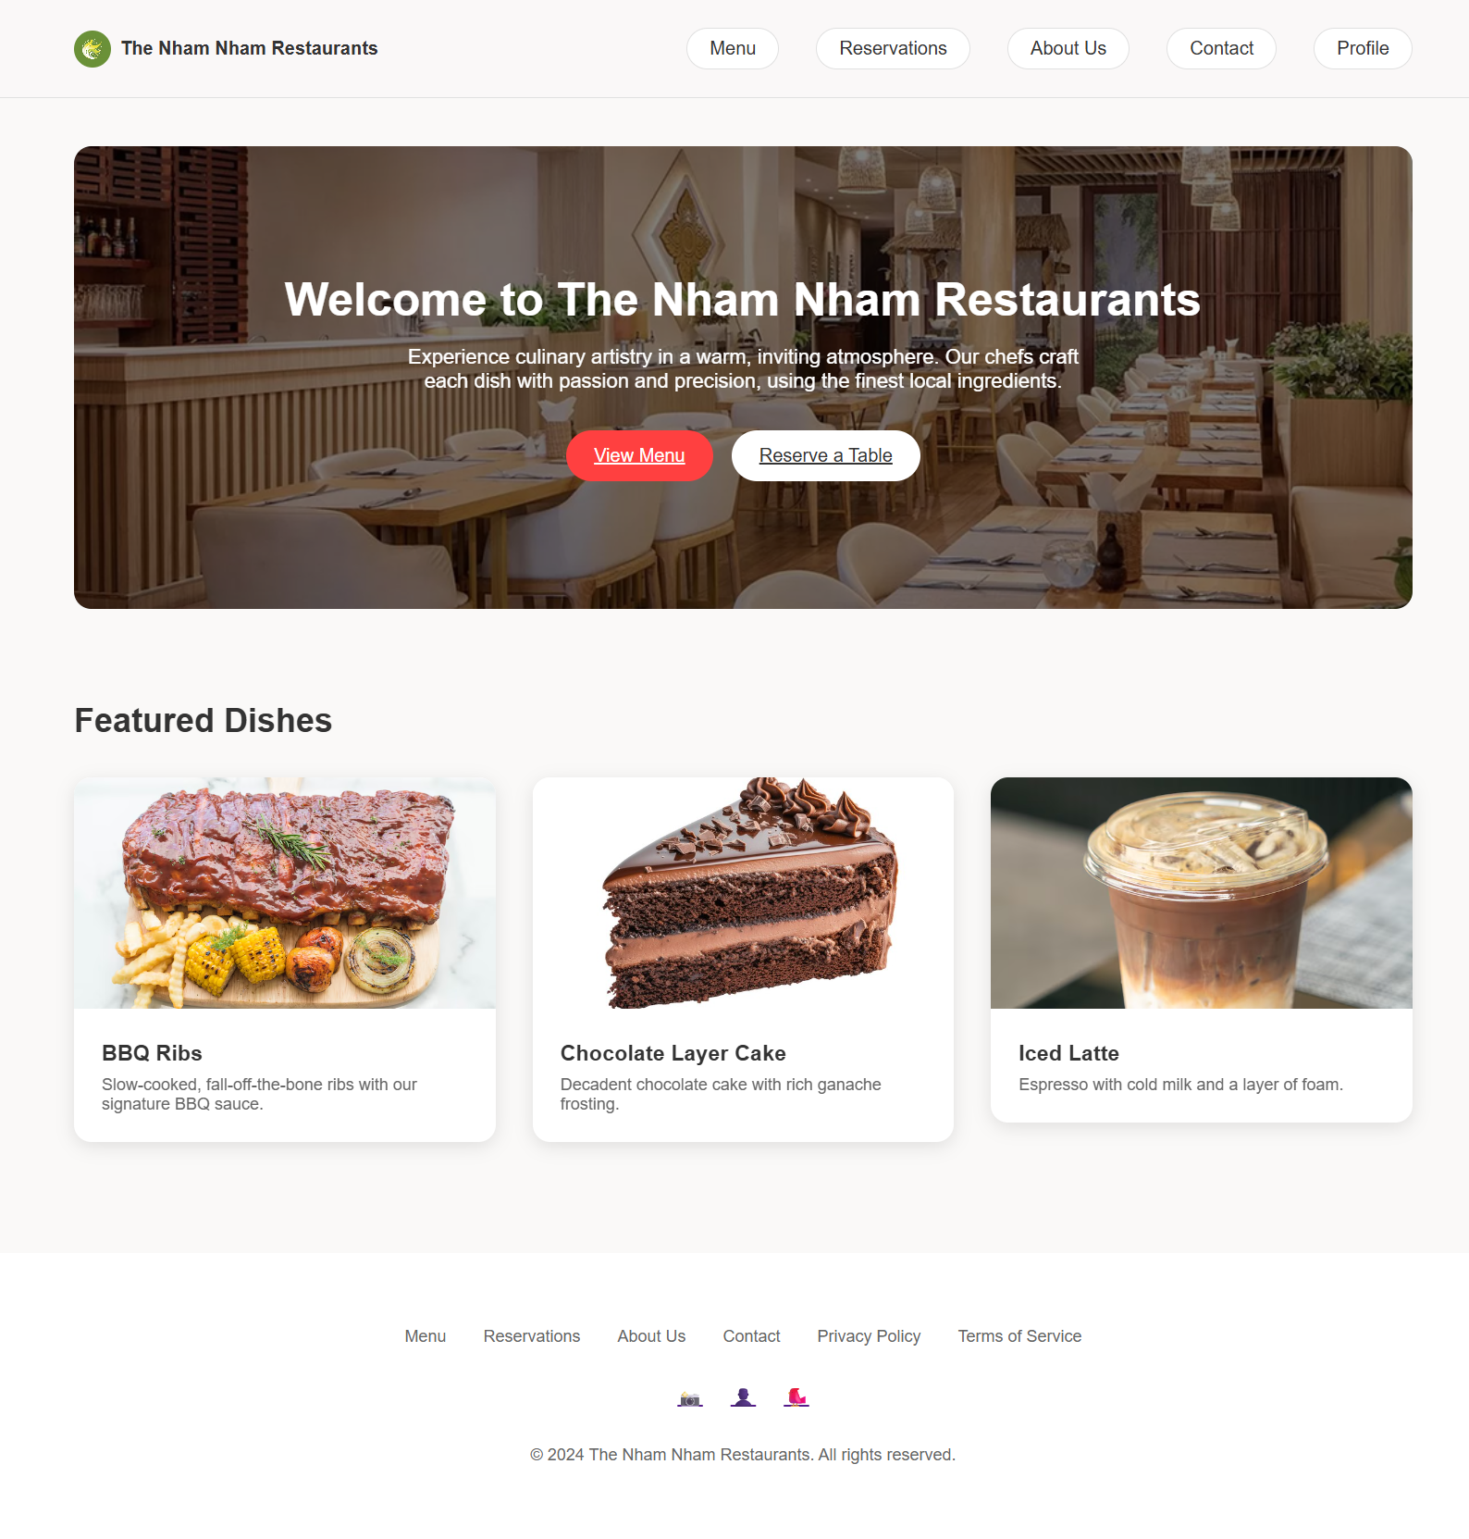 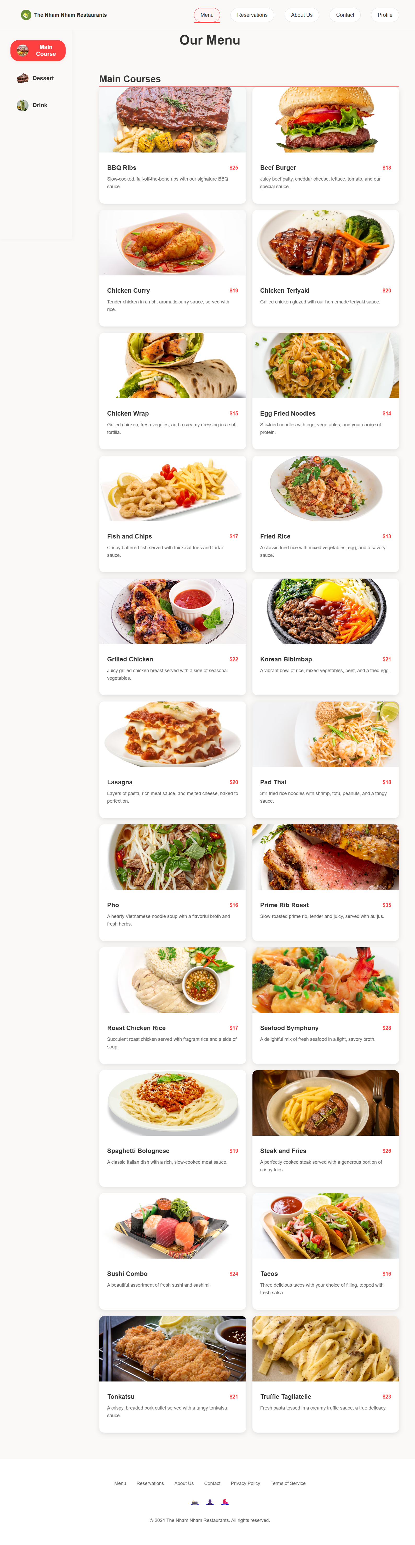

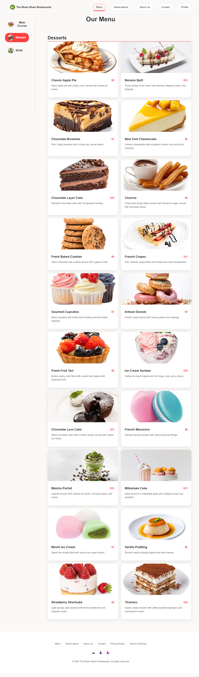 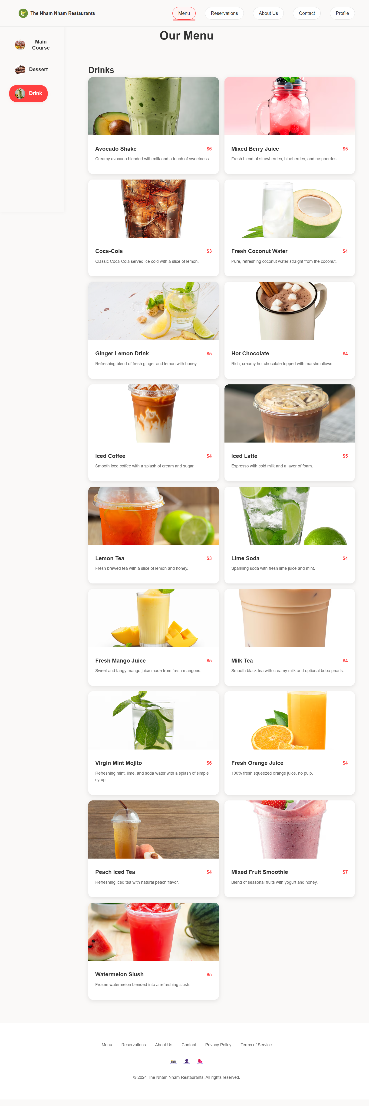 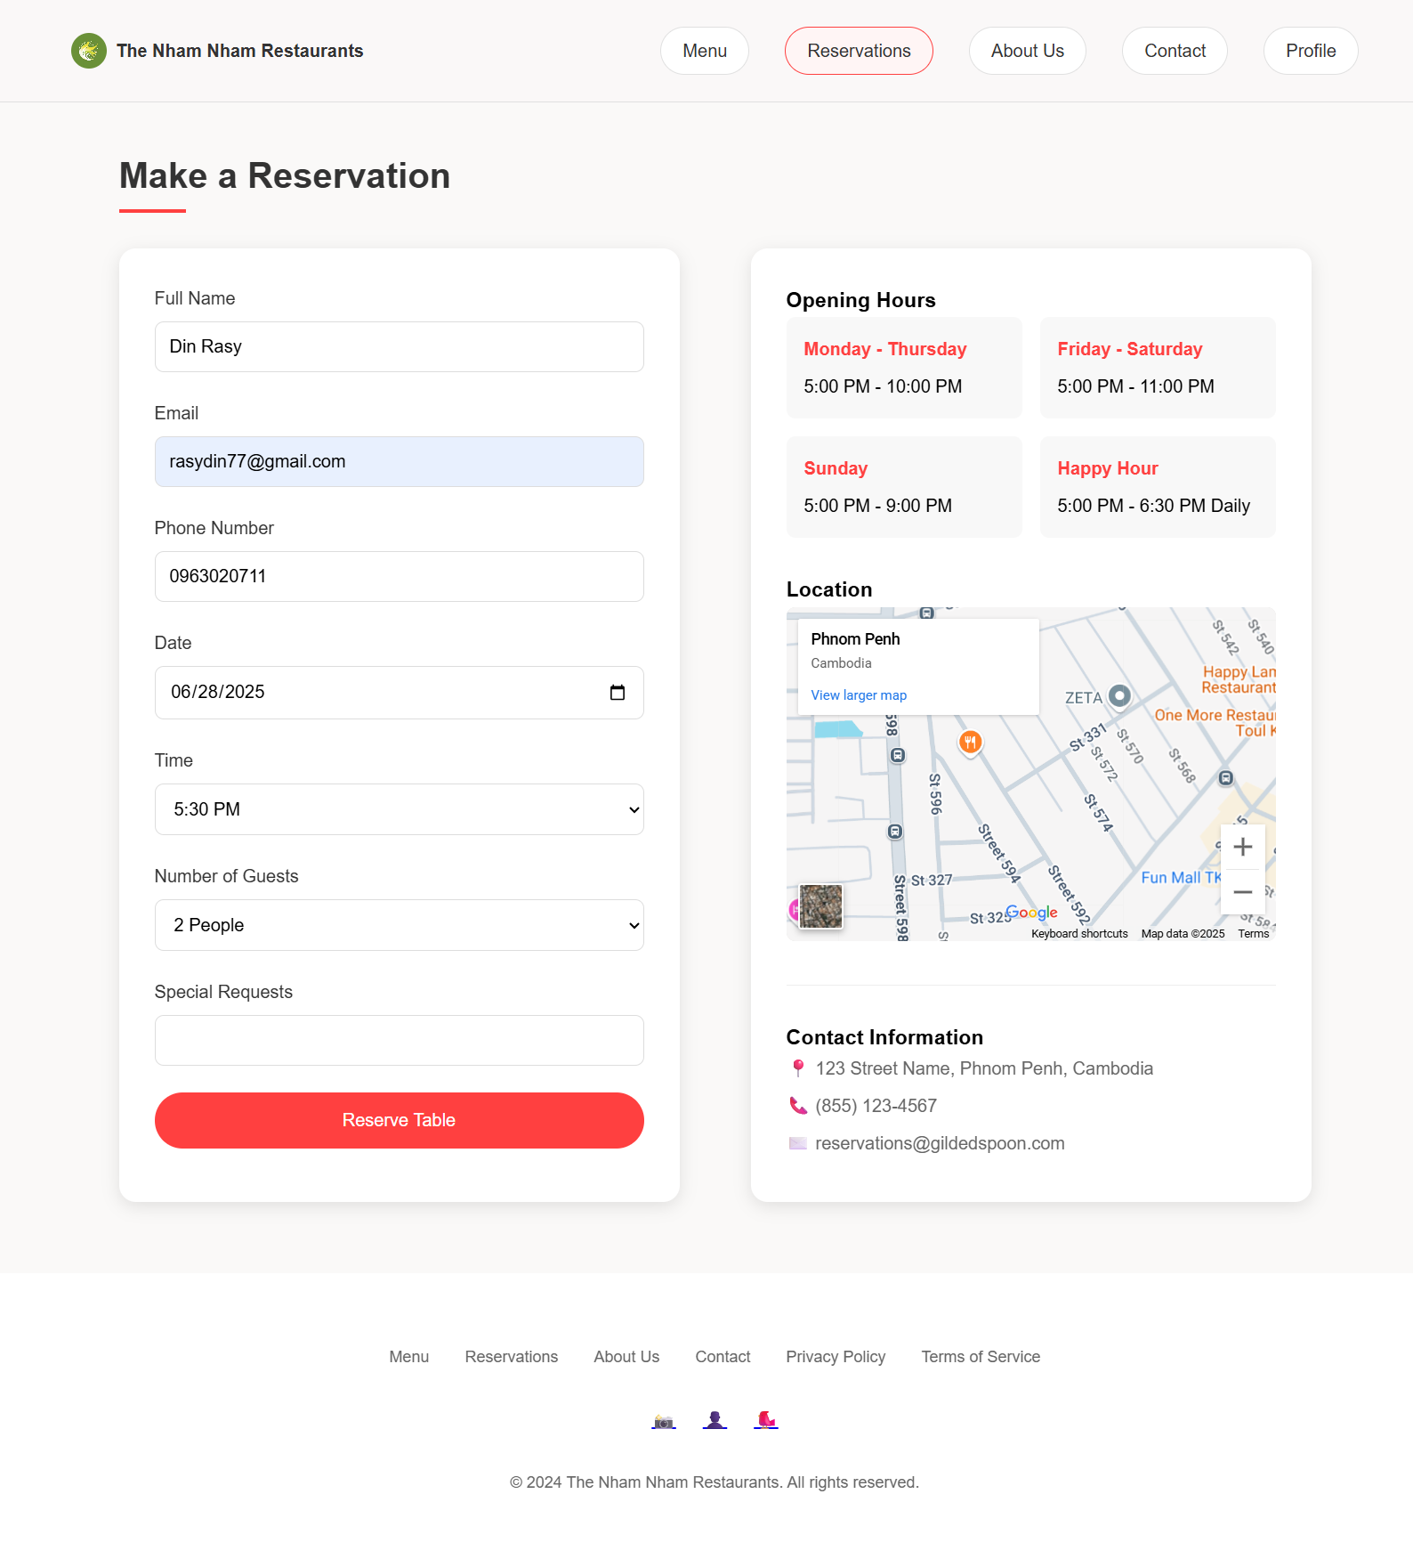 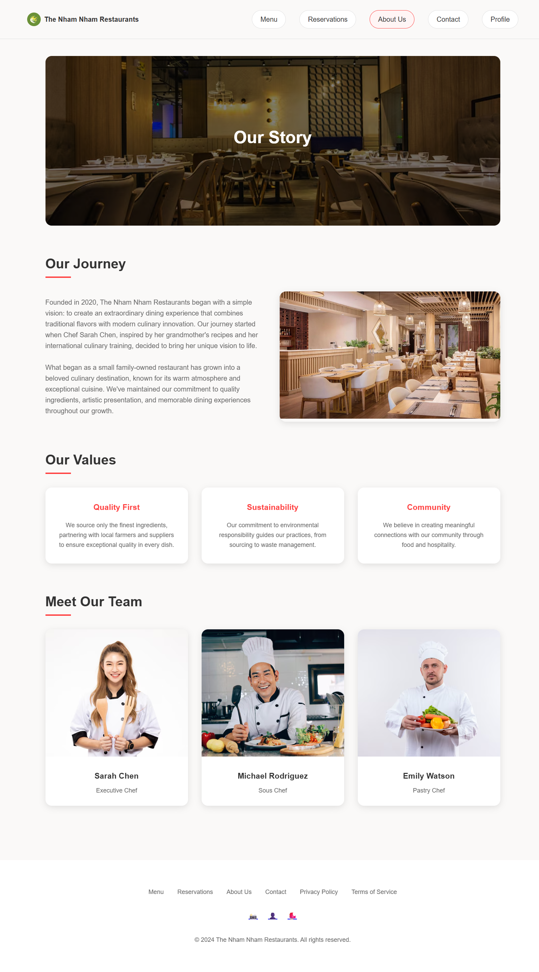 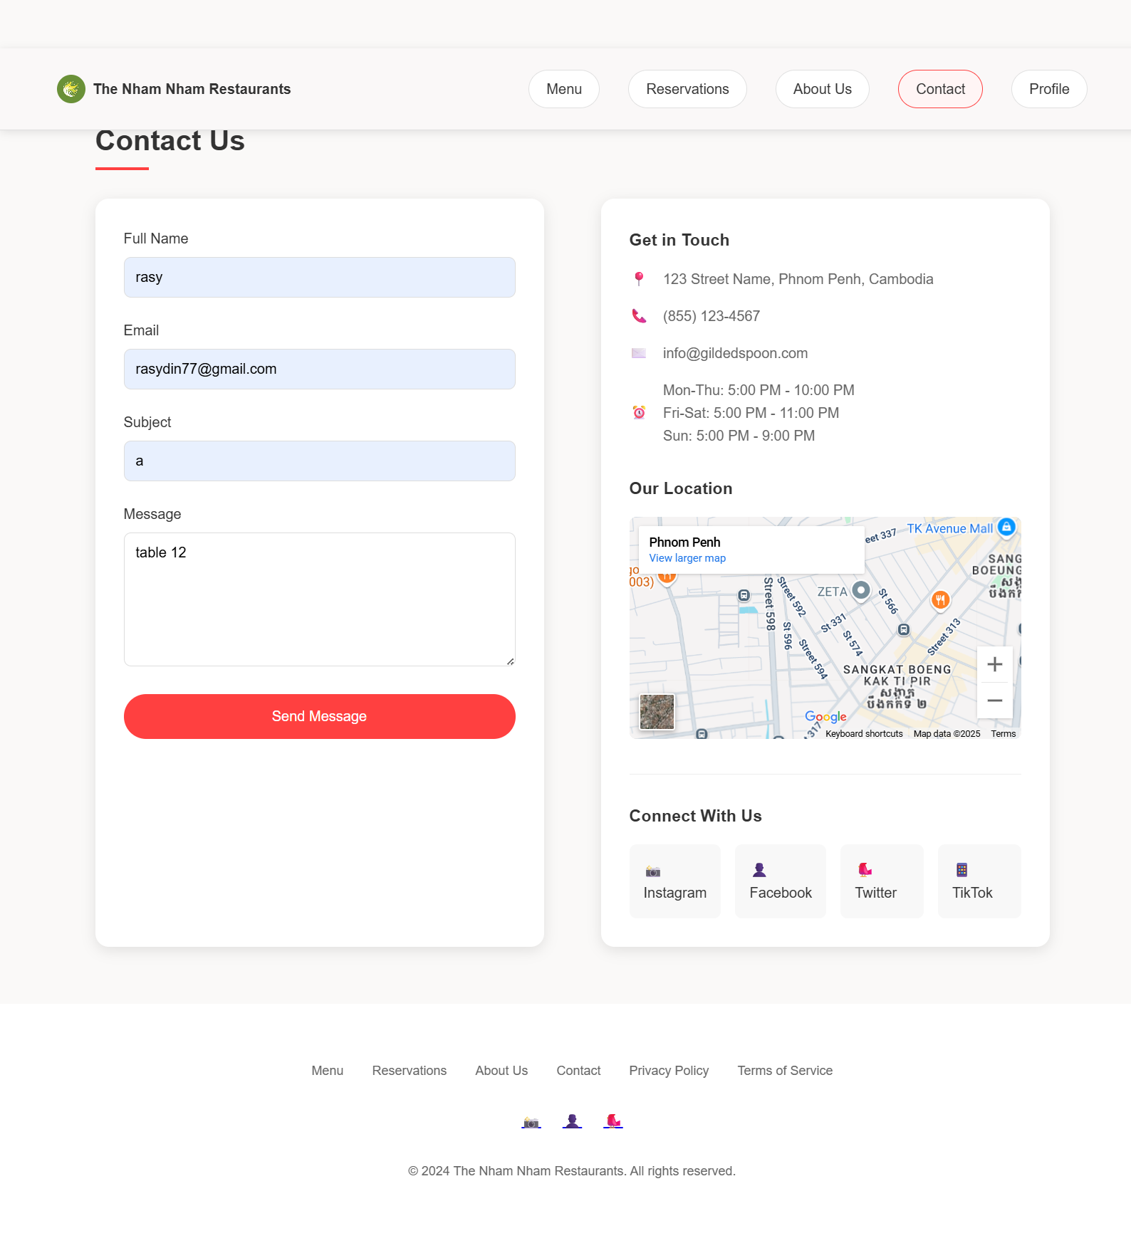 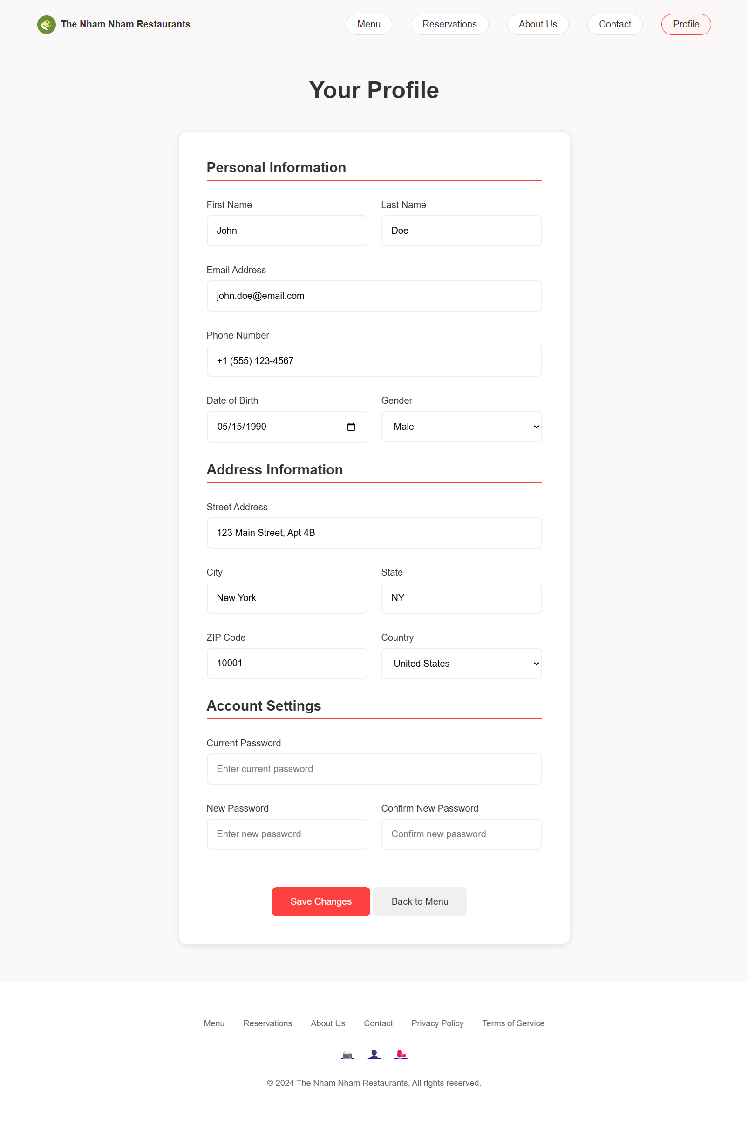 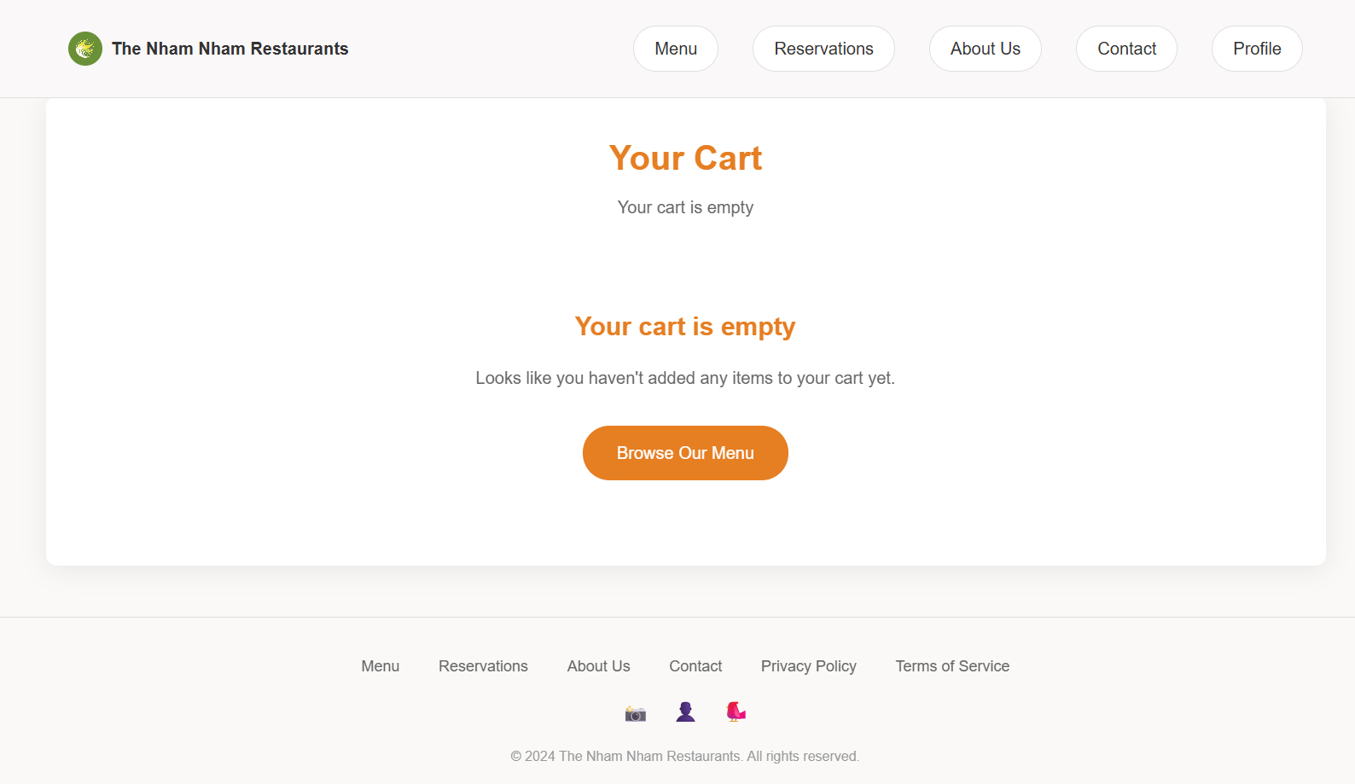

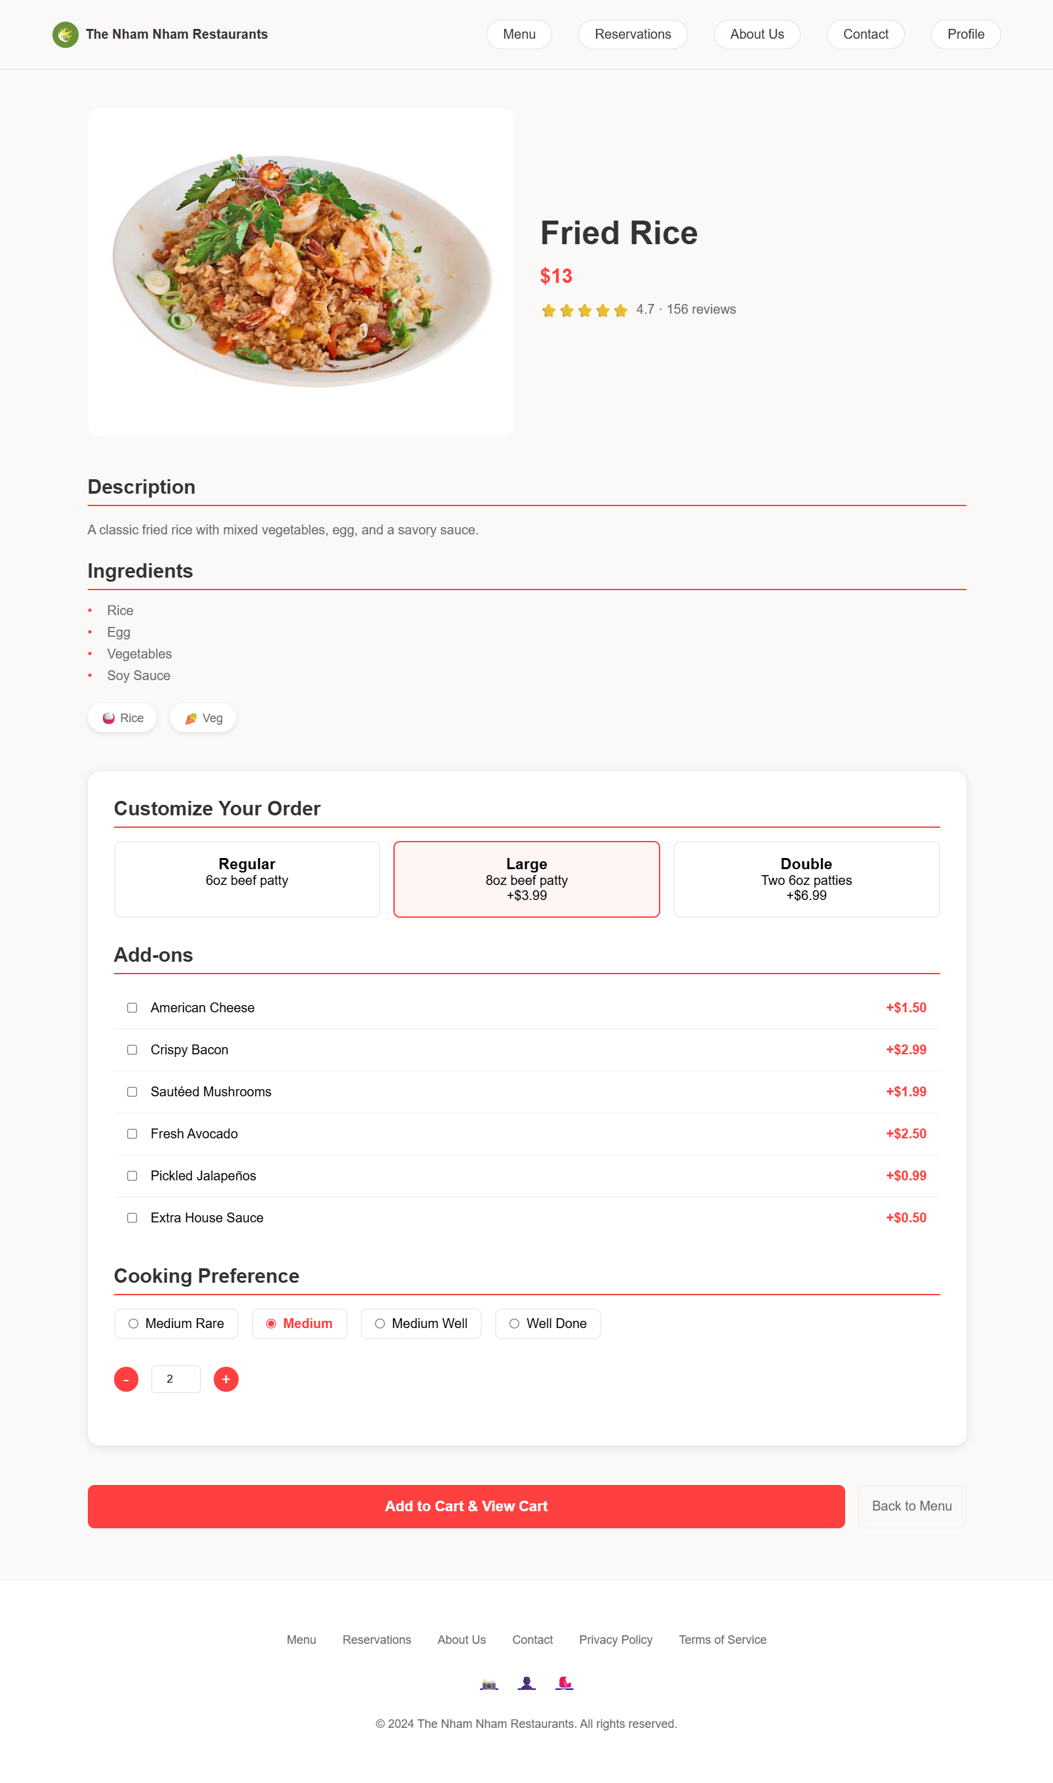

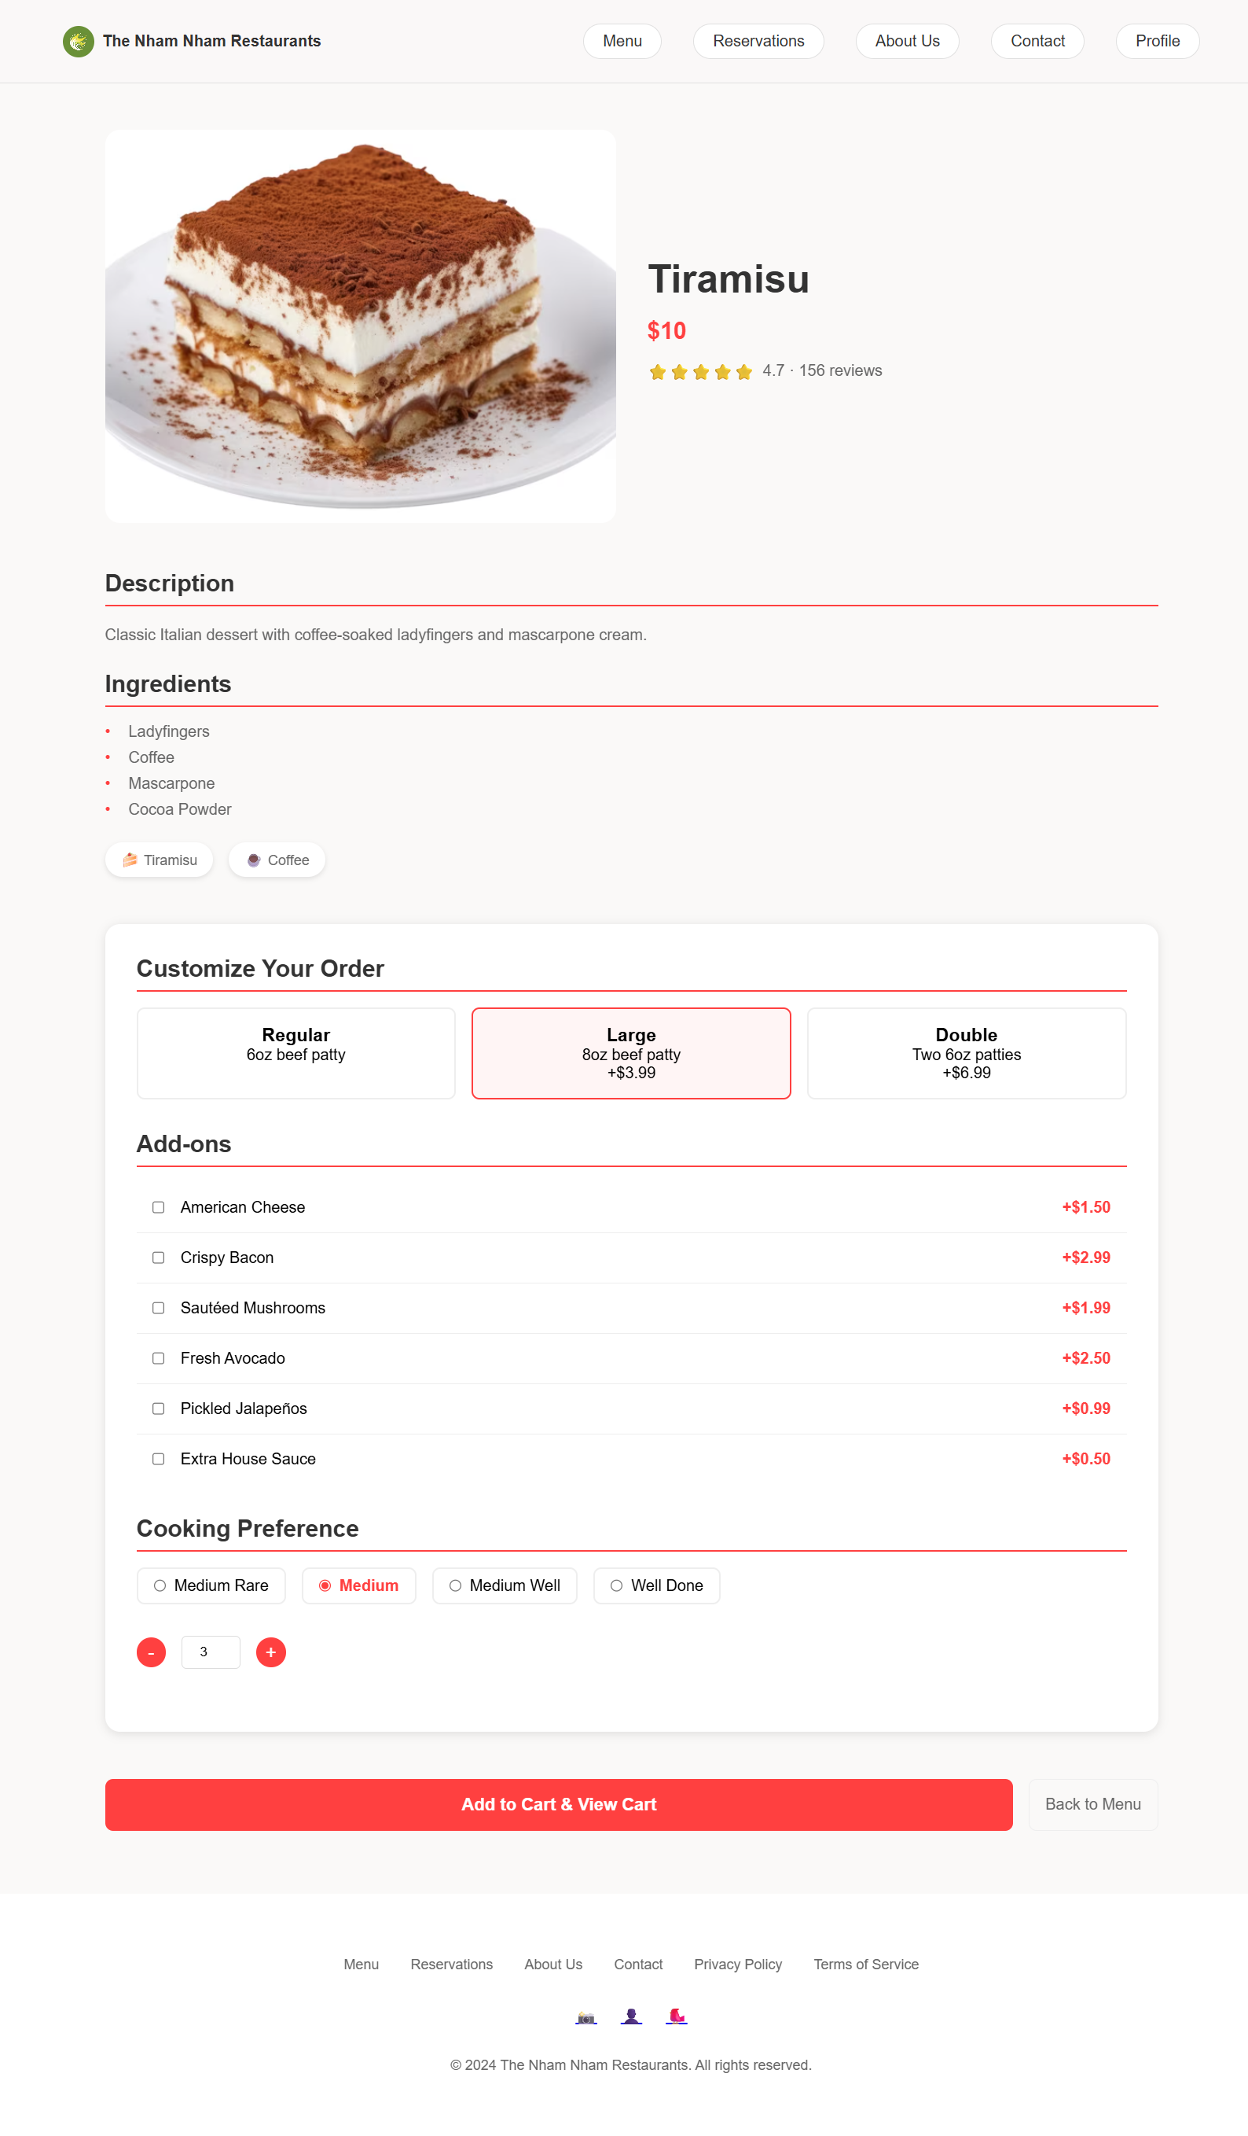 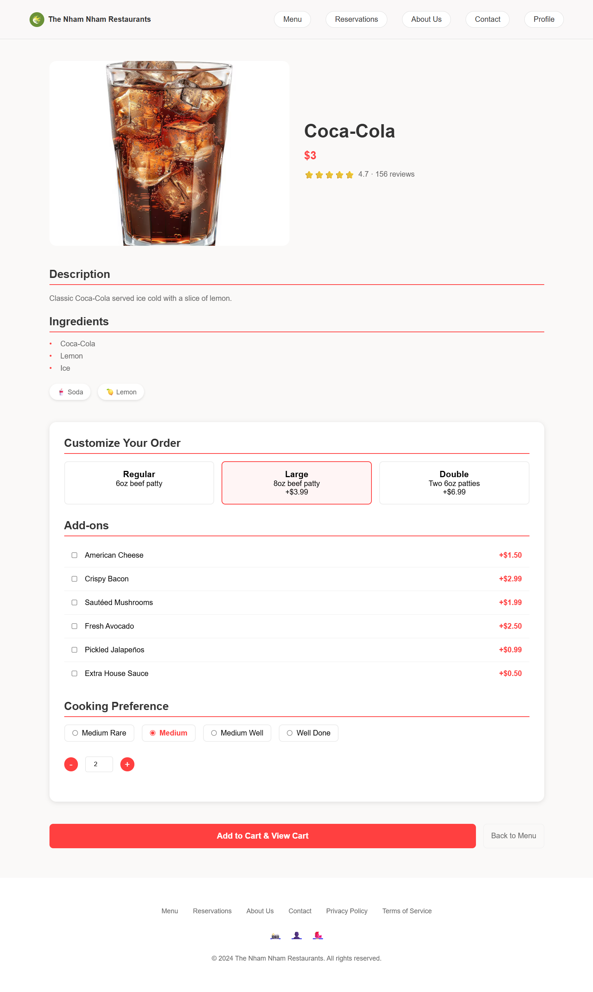 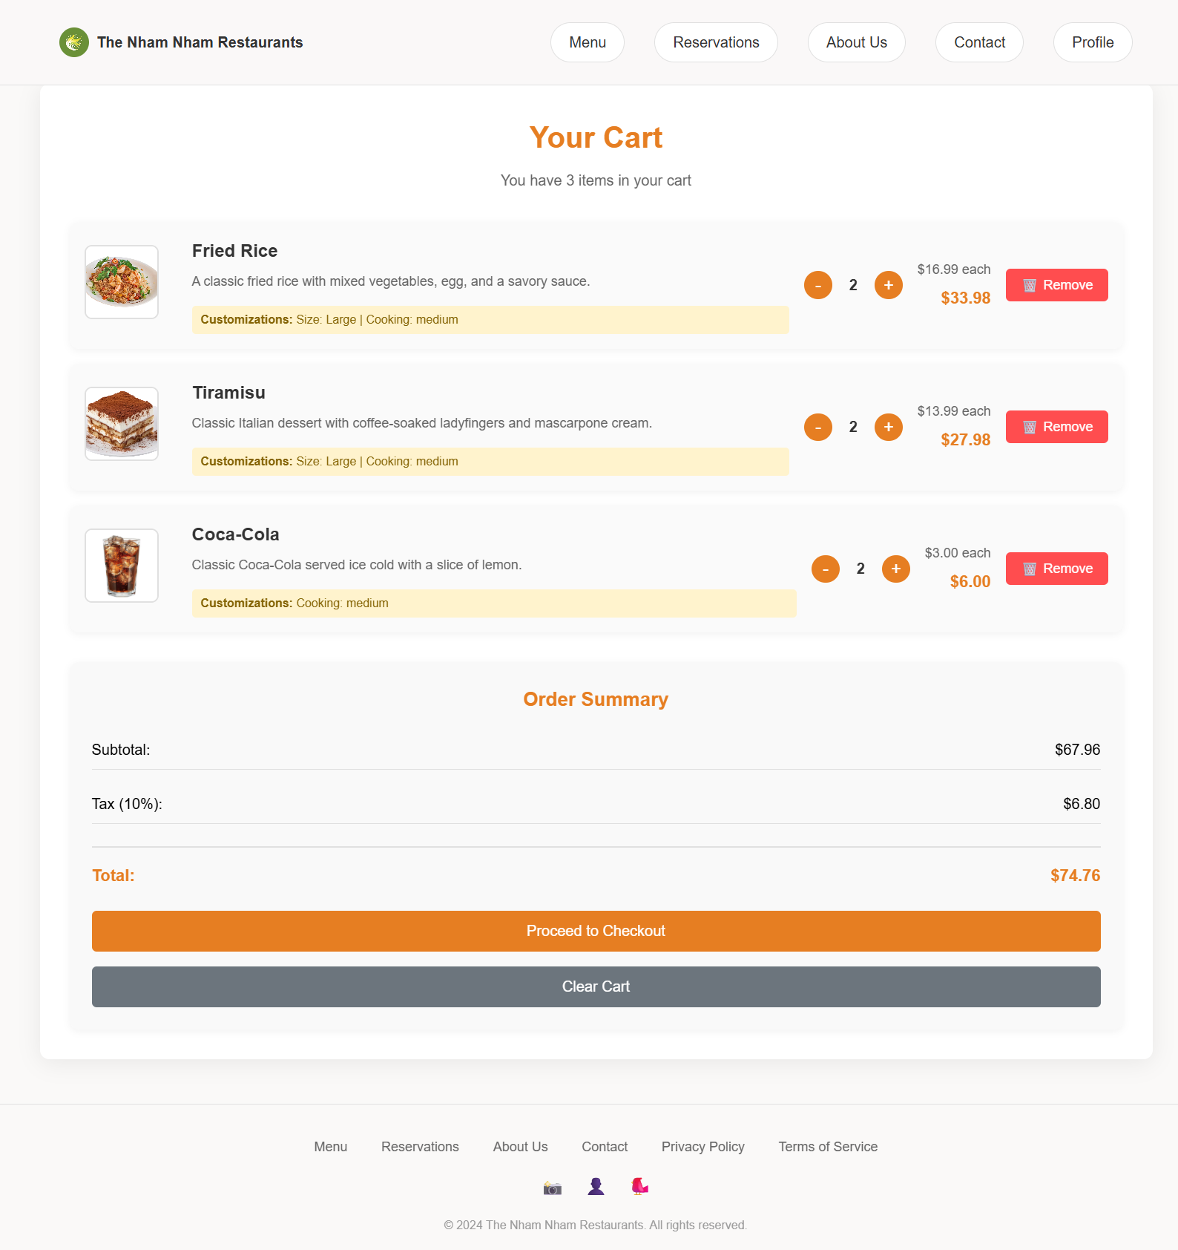

1. **Conclusion**

The Nham Nham Restaurant website is a well-planned and executed food service platform. It targets busy modern users and solves real problems around convenience and meal planning. With clear structure, responsive design, and strong visuals, it meets both user and project requirements.